Block 2 Checkoff

Transformer

**Transformer Block Introduction**

The transformer block includes the transformer which steps down the 120VAC to 5VDC as well as the voltage regulator that converts the 5V to 3.3V. The transformer was salvaged from a Vogek ST270 USB Wall Charger, shown in Figure 1. We removed the USB connectors and connected the transformer to our PCB using an XT30 connector, shown in Figure 4.

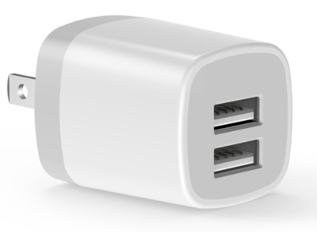

Figure 1. Vogek ST270 USB Charger

**Block Diagram**



Figure 2. Block diagram for Transformer Block

**Interface Definitions**

|  |  |
| --- | --- |
| Interface | Properties |
| **fused_acpwr** | INominal : 0 - 3A (depends on what’s plugged in)  Imax : 5A  Vmax : 125VAC  Vmin : 115VAC |
| **mcu_dcpwr** | INominal : 100mA  Imax : 125mA  Vmax : 3.3V  Vmin : 3V |
| **node_dcpwr** | INominal : 261mA  Imax : 296mA  Vmax : 5.5V  Vmin : 4.0V |

**Schematics**

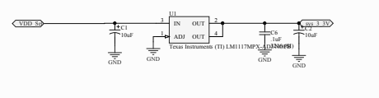

Figure 3. 5V to 3.3V Regulator

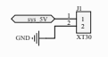

Figure 4. XT30 Connection from transformer to PCB

**Testing Plan**

This block is fairly simple in operation and has the benefit of being a pre-built solution. It must be able to receive 120VAC power (**fused_acpwr**) and transform that down to 5V nominal @ up to 1.5A (**mcu_dcpwr** and **node_dcpwr**).

Power Functionality

1. Begin with everything de-engerized/powered
2. Connect leads to the **node_dcpwr** and **mcu_dcpwr** lines and plug them into a programmable dc load
3. Provide 120VAC power to **fused_acpwr**
4. Measure the voltage output on the DC load side (either with a DMM or the load itself)
5. Ensure the voltage does not go above/below the nominal voltage
6. Activate the load at 0A and slowly increase current draw until 1.5A is being drawn
7. During this time, ensure voltage does not go above/below nominal
8. Leave load at 1.5A for ~10-15min and watch for any voltage discrepancies